1. Employee DB

i] OUTPUT AFTER INSERTION

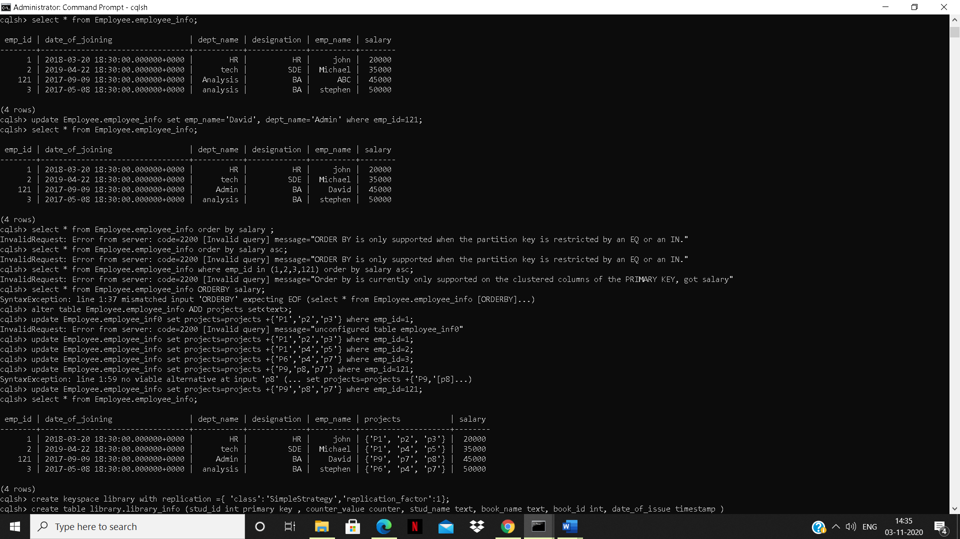

ii] OUTPUT AFTER UPDATE



iii]OUTPUT AFTER ALTER

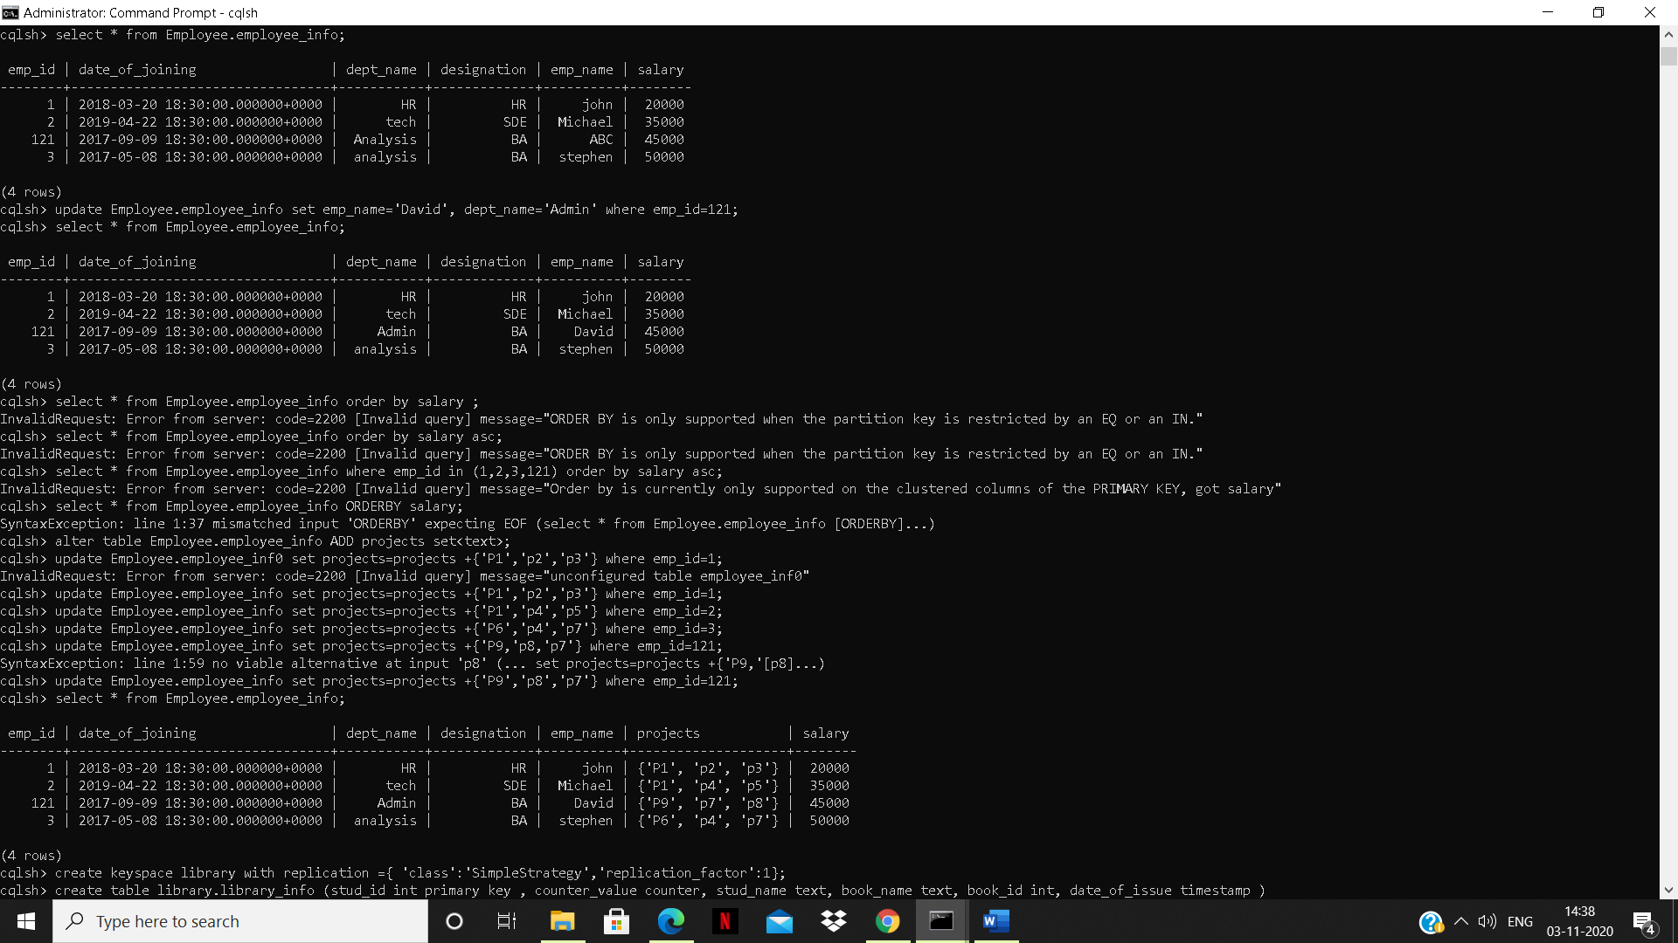

iv]TTL

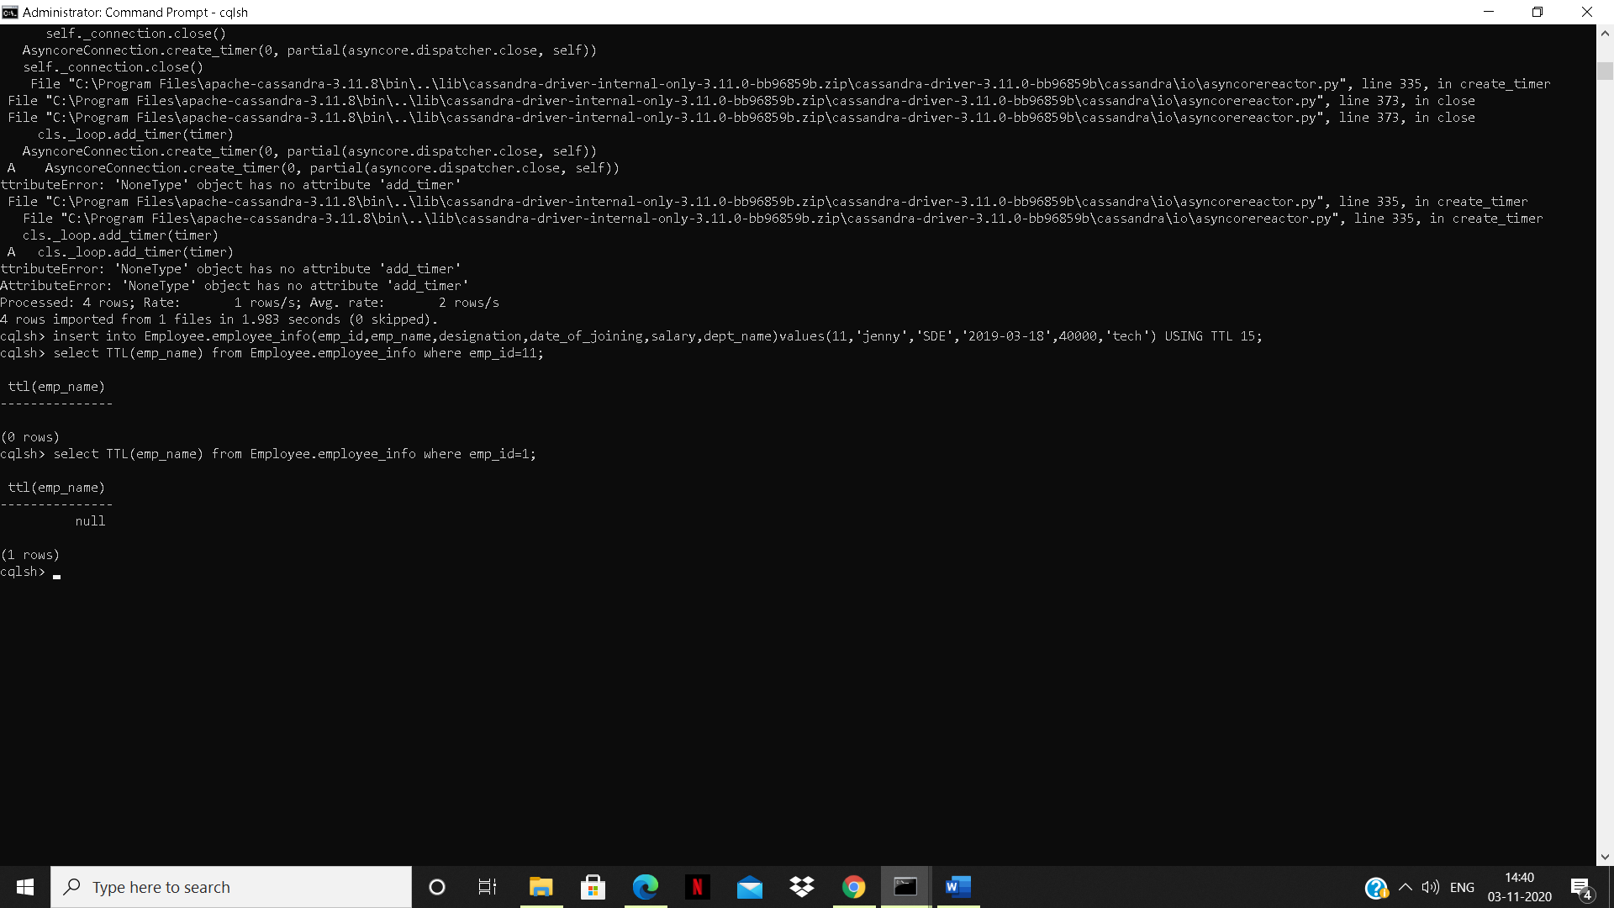

2. LIBRARY DB

i] OUTPUT AFTER INSERTION

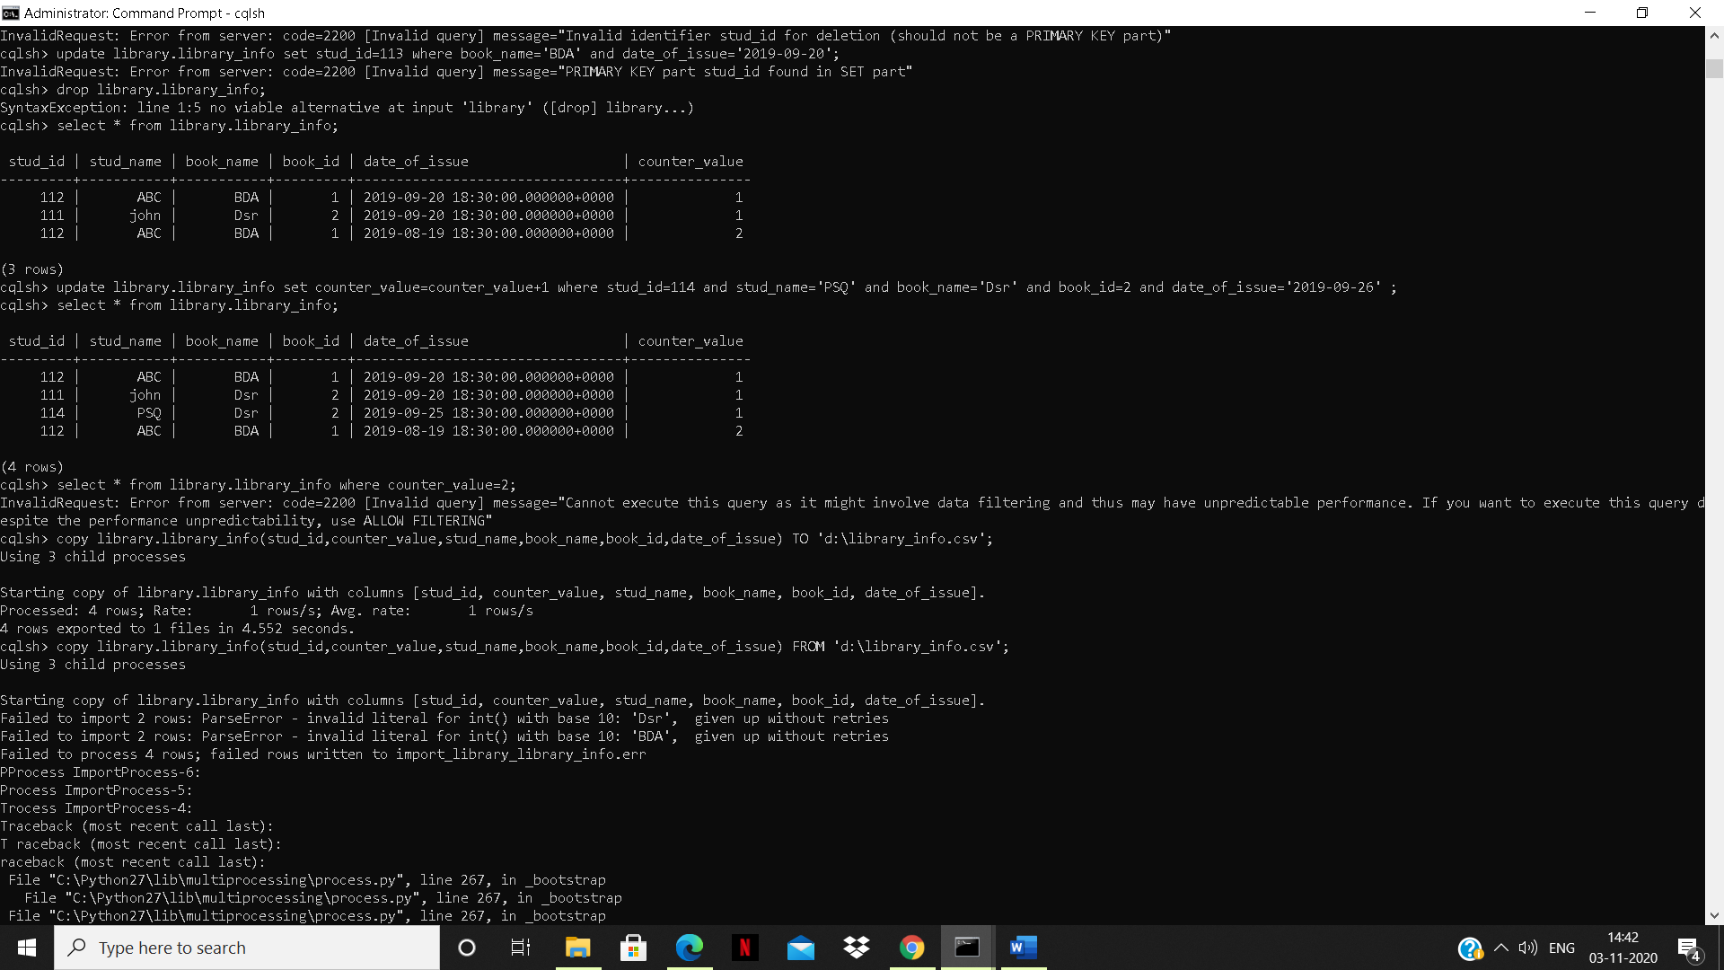

ii] Export

